These go with the study Custom Function Exercises on the PRA sandbox

Ex1 - If CONMEDS.CMTERM contains the word 'aspirin' (ignore caps) then fire a query to site on CMTERM 'Subjects are not allowed to take Aspirin'. Harder version: modify it so that it doesn’t fire this query for aspirin taken on the subject’s birthday (i.e. if CMSTDAT = CMENDAT = DM.BRTHDAT + some whole number of years).

AECN check: relationship = related, AE start < CM term start

**LFB trail example.**

**if (dpAction != null) means is not null**

**|| means “or”**

**&& means “and”**

**Marking group 1 = site**

**“_Cross” artifact name from MEDIDATA (it could be named <editname>_v1, v2, etc)= AEYN and AE have to have different RAVE edits to call the same c# custom function (one for AEYN and one for AE named “cross”).**

**AEYN: just checking AEYN exists and call to the c# defines Y or N**

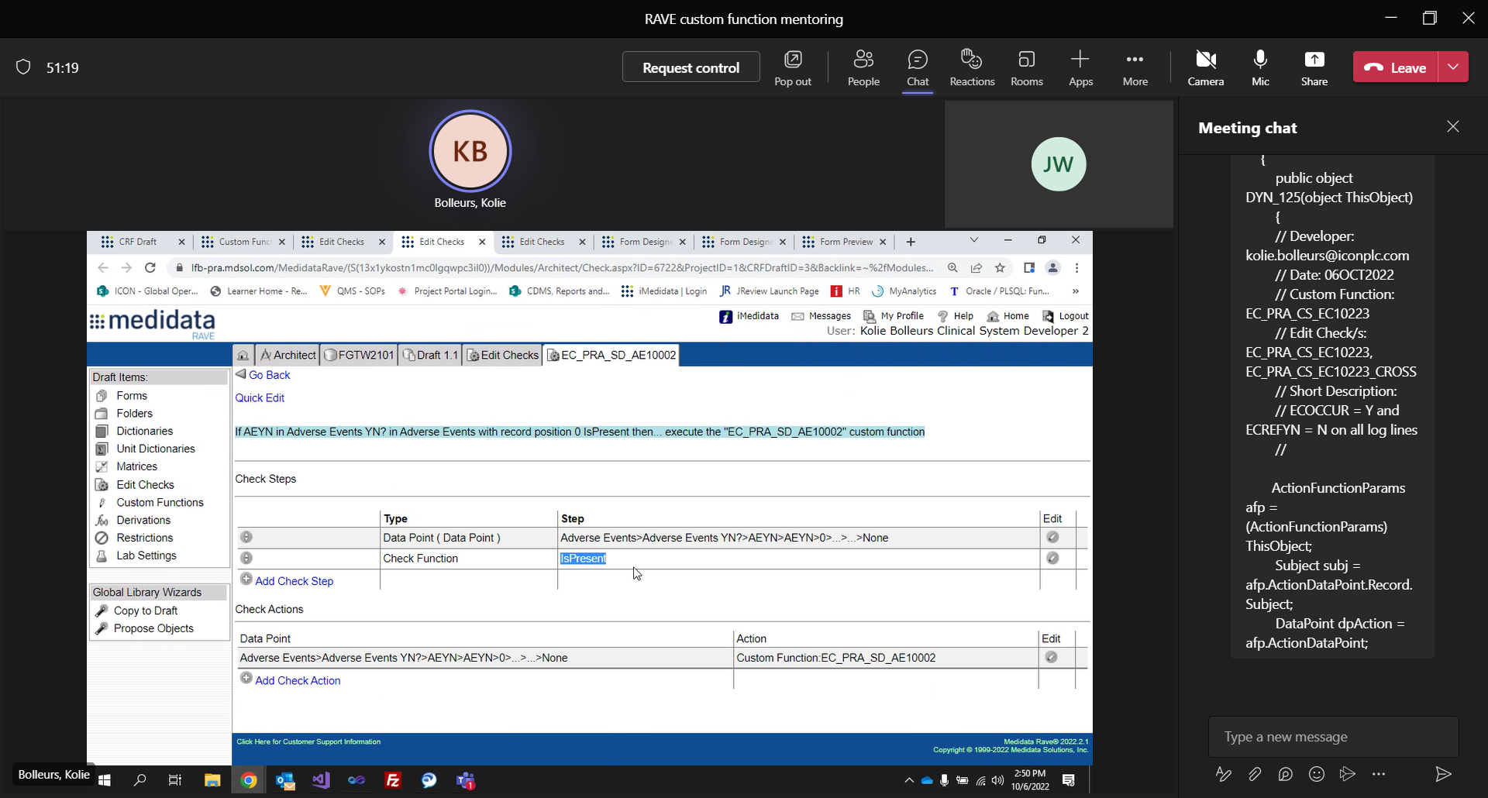

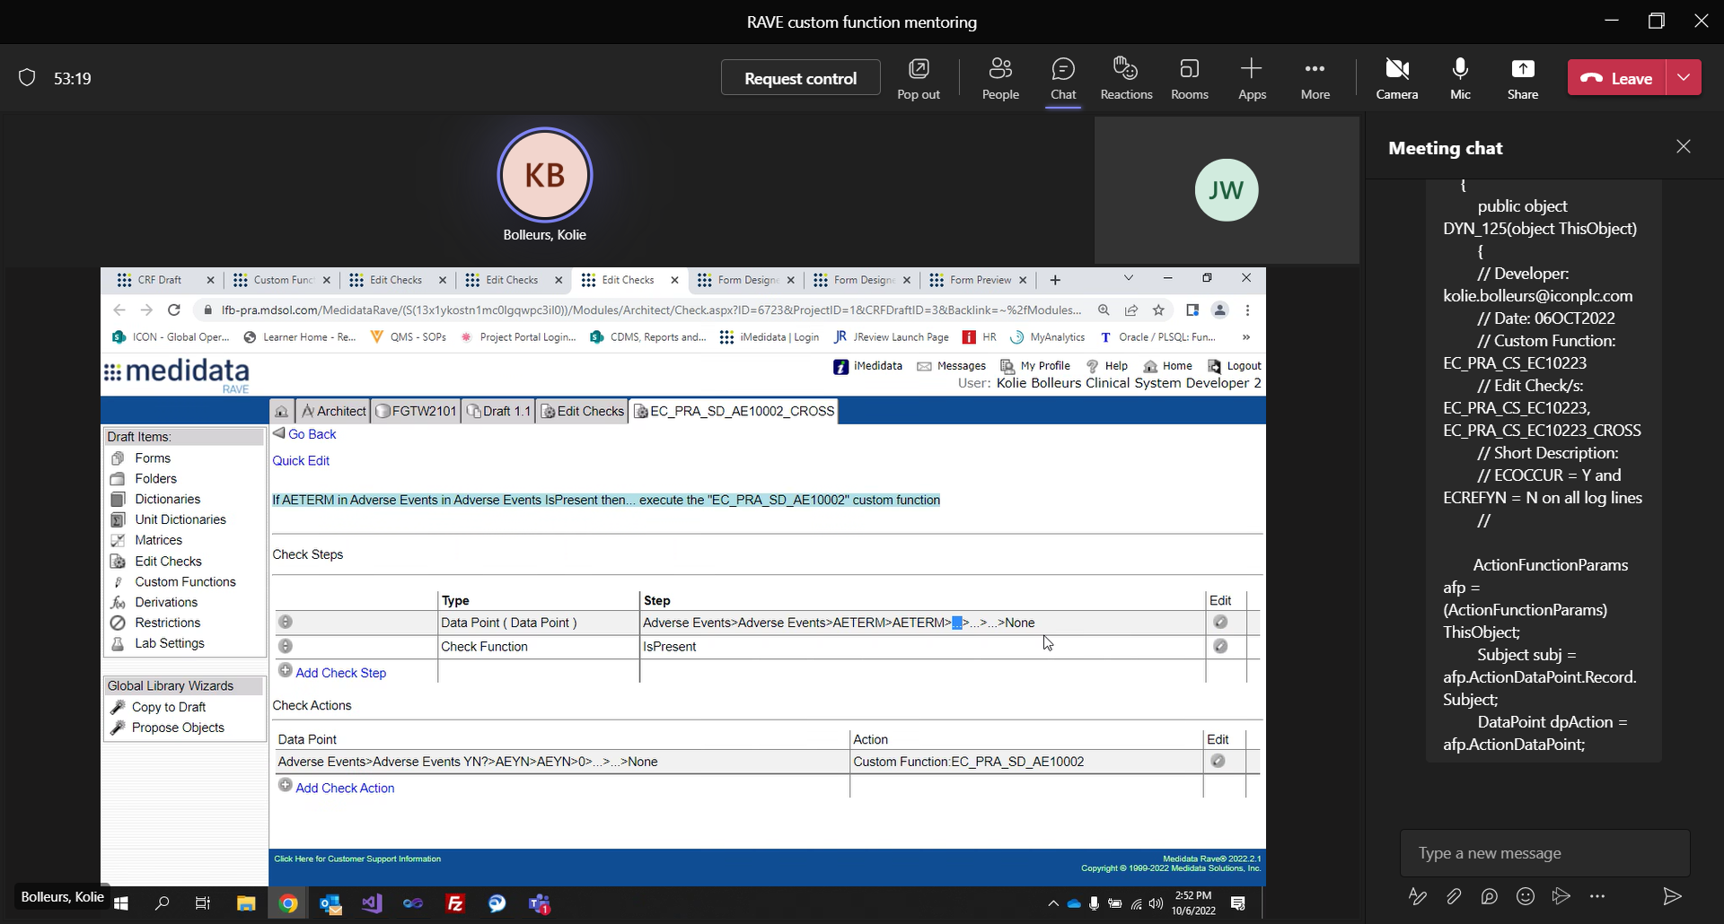

**Reminder: you must use CF for an edit that references a field that can “not be visible” based on DYN trigger.**

CONTAINS c# function

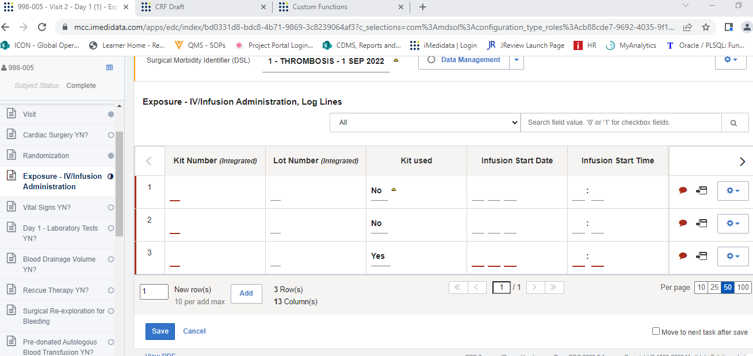

Not all No so the query will not fire

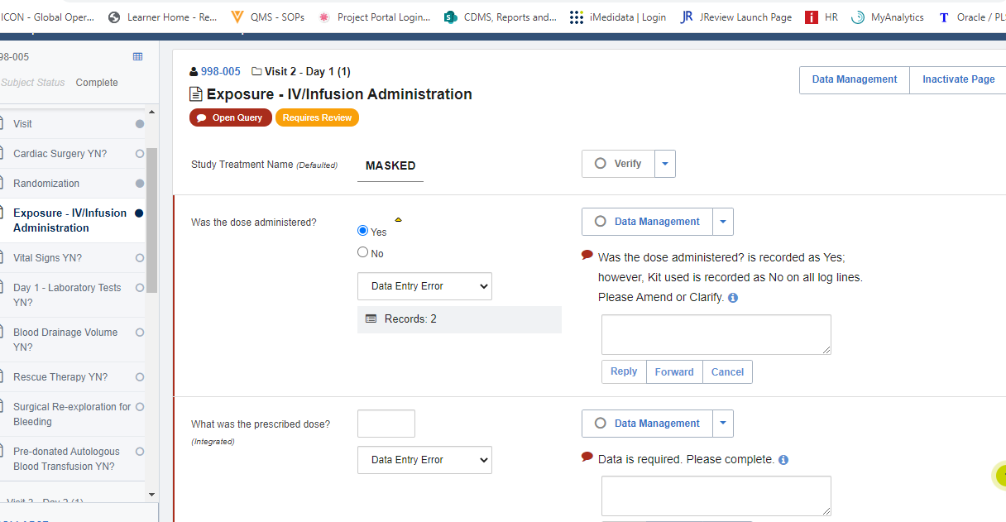

|EC_PRA_CS_EC10223|True|True

       ||DataPoint|ECOCCUR||ECIV|ECOCCUR|0||||||  
        IsPresent|||||||||||||  
        ||DataPoint|ECREFYN||ECIV|ECREFYN|||||||  
        IsPresent|||||||||||||  
        Or|||||||||||||

       |ECIV|ECOCCUR|ECOCCUR|0||||||CustomFunction||EC_PRA_CS_EC10223|

       // Developer: kolie.bolleurs@iconplc.com  
        // Date: 06OCT2022  
        // Custom Function: EC_PRA_CS_EC10223  
        // Edit Check/s: EC_PRA_CS_EC10223, EC_PRA_CS_EC10223_CROSS  
        // Short Description:  
        // ECOCCUR = Y and ECREFYN = N on all log lines  
        //

       ActionFunctionParams afp = (ActionFunctionParams) ThisObject;  
        Subject subj = afp.ActionDataPoint.Record.Subject;  
        DataPoint dpAction = afp.ActionDataPoint;

       int count = 0;  
        bool fireQuery = false;  
        string queryText = "Was the dose administered? is recorded as Yes; however, Kit used is recorded as No on all log lines. Please Amend or Clarify.";  
        int markingGroup = 1;

       bool requiredResponse = false;  
        bool manualClose = false;

       Records rcdsECREFYN = dpAction.Record.DataPage.Records;

       if (dpAction != null && dpAction.Data != string.Empty && dpAction.Data == "Y")  
        {  
            fireQuery = true;  
            if (rcdsECREFYN.Count == 1)  
                fireQuery = false;  
            else  
            {  
                for (int i = 0; i < rcdsECREFYN.Count; i++)  
                {  
                    Record rcdECREFYN = rcdsECREFYN[i];  
                    if (rcdECREFYN.RecordPosition > 0)  
                    {  
                        DataPoint dpECREFYN = rcdECREFYN.DataPoints.FindByFieldOID("ECREFYN");  
                            if (dpECREFYN != null && dpECREFYN.Active && (dpECREFYN.Data == string.Empty || dpECREFYN.Data == "Y"))  
                                fireQuery = false;    
                    }  
                }  
            }  
        }

       CustomFunction.PerformQueryAction(queryText, markingGroup, requiredResponse, manualClose, dpAction, fireQuery);

       return null;

ex2 – If AETERM = CMTERM, fire a query on CMTERM ‘Oh look, a pill with the same name as an AE’. Make sure the query disappears when the AE is inactivated. Hint: 2 edits are needed here.

ex3 - If the same value of DSIC.PROTVER is entered on more than one log-line, fire a query to site on PROTVER 'Same protocol version has been selected for more than one log-line'. Harder version: See if you can get the CF to only fire a query on the first duplicate entry.

ex4 - If subject has consented to Protocol Version 3 and EGPERF.EGPERF = Y at any visit then add the form ECG1 to the current folder. If subject has not consented to Protocol Version 3 and EGPERF.EGPERF = Y for any visit apart from EOS, then add the form ECG1 to the current folder (so ECG1 should not appear in EOS unless the subject is on version 3). Make sure it works if a subject consents to version 3 and subsequently data is updated so they don't consent to version 3 any more (it will need to inactivate EOS.ECG1 in this case, provided no data is present on the form).

ex5 - if CONMEDS.CMSTDAT < MIN(DSIC.DSSTDAT) then fire query to Data Manager 'Only con meds should be recorded’. Make sure it fires if a DSIC record is inactivated so that MIN(DSSTDAT) changes, in such a way that some con med is now rendered less than MIN(DSSTDAT).

ex6 - Set CMAENO equal to a dynamic search list of all AE records in the form X-AETERM-AESTDTC, where X is a three digit number representing the record position (so for record position 1, X = 001). HINT: CMAENO starts off having format LongText, this is because rave doesn’t let you put the format to Dynamic SearchList unless you’ve already put in your CF. So you’ll need to change this at the same time as putting in your code and associated edit. DSLs are a bit different from most CFs in that you use the check action Set DynamicSearchList instead of Custom Function. HINT: Don’t steal this code from the PRA standards, the standards are riddled with errors so avoid them (until you know what you’re doing and can fix them as you go).

Ex7 - Modify the CF from ex6 so that it sets CMAENO non-conformant and fires a query on it if the corresponding AE is modified or inactivated. HINT: You'll need to add another CF to do this, call it EX6_CROSS say, and two edits calling EX6_CROSS.

Ex9 - If VISU.ECG1 or VISU.HEM = 1 and the corresponding form OID <> submitted and EOS.DSDTC <> empty then fire a query to site on ECG1/HEM as applicable 'Assessment has been checked; however, the corresponding form has not been entered. Please reconcile.'

Ex10 – If a serious AE is added, add a copy of the SAE form to the AE folder and enter the data from AETERM in AEDESC (truncate it to 50 chars), and AESTDAT in SAEDATE. Also enter the AE recordposition in AENUM. If the AE then inactivated, the corresponding SAE form should also be inactivated (How to find the right SAE form to inactivate? Good job we included AENUM, use it). Rename the SAE form ‘Serious Adverse Event – AETERM – AESTDAT’.